Shared Global Mandate to Lower Carbon Emissions and provide Clean Affordable Energy for All

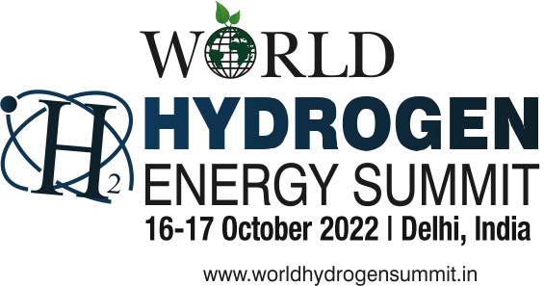
Registration Form
[Prior Registration is mandatory]
I / We would like to participate / nominate the following for the Summit:

Sl. No | Name | Designation | Mobile | Email
1
2
3
4
5
Organization / Institute / University:

Address:

Ticket Type Price Quantity

Delegate Pass INR 22000 | US$ 400
All Days Access to the Premium Conference Plus 18% GST
Author Pass INR 20000 | US$ 400
All Days Access to the Premium Conference Plus 18% GST
Student Delegate Pass INR 8000 | US$ 200
All Days Access to the Premium Conference Plus 18% GST

PAYMENT METHOD
For Electronic Transfer | For UPI Payment
Account Name : Energy And Environment Foundation
Account Number : 629705015384
Branch : ICICI Bank Ltd.
C-24-25, Acharya Niketan, Mayur Vihar-I
Delhi-110091, India
IFSC Code : ICIC0006297
Swift Code : ICICINBBCTS

NOTE: Send participants Name, Mobile, Email and Payment Receipt at dranilgarg2011@gmail.com
Please complete the form and mail/fax/email
Dr. Anil K. Garg, CEO, Energy And Environment Foundation | Ph.: 91-11-22758149, 22757049
Punit Singh, Senior Manager | Ph.: 9213901510
www.worldhydrogensummit.in

